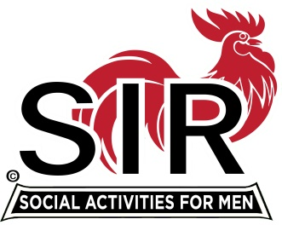
Las Trampas Branch 116
Meeting Agenda
September 21, 2020, 11:45 AM
The Mission of SIR is to enhance the lives of our members through fun activities, events and luncheons – while making friends for life

11:45 Social Time

12:00 BIG Sir: Welcome

12:05 Little SIR: Introduction of Speaker: Gregory Crouch

12:40 Little SIR: Speaker “Thanks.’

12:45 BIG SIR: Bogus email solicitation

12:50 Activities: Fred Wachowicz
Bernie Wroblewski

1:00 Little SIR: Birthday Boys

1:15 Big Sir: Close Meeting

